Bedford & Kempston Conservative Association
Political Supper
with Sam Gyimah MP
Minister of State for Universities, Science, Research and Innovation
** An opportunity to thank Richard Fuller for his many years as our MP **
Friday 12th October 2018, 7pm for 7.30pm

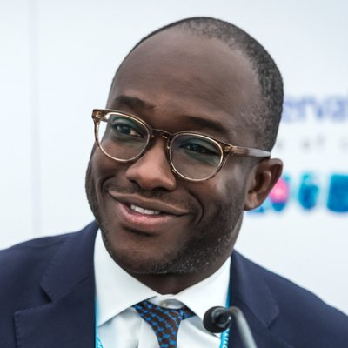

£25 per person or £15 for Young Conservative members under 23
Includes a two course meal and one free glass of wine/soft drink
Renhold Village Hall, Wilden Road, Bedford MK41 0LY
----------------------------------------------------------------------------------------------------------------------------------------------------------------------------------------------------------

Name(s): ___________________________________________________________________________

Please reserve ____ place(s) for me at the Political Supper with Sam Gyimah MP on 12th October 2018. Please note that bookings cannot be accepted without payment.

If you wish to sit with specific other guests, please list their names below

I have (please delete as appropriate)
- enclosed a cheque, made payable to BKCA for £____________ or
- paid £________ by BACS Transfer to Sort Code 20-05-74, Account Number 83131823 quoting 12October followed by my surname in the reference box

Please list any dietary requirements: -_______________________________________________________________________________________
Forms may be posted to Dee Dite, 41 Thor Drive, Bedford MK41 0WN or emailed to bkca@btconnect.com
The last date for booking is Thursday 4th October.

